

Emergency dissemination in VANETs
Boris Gor
Supervisor: Prof. A. Al-Anbuky
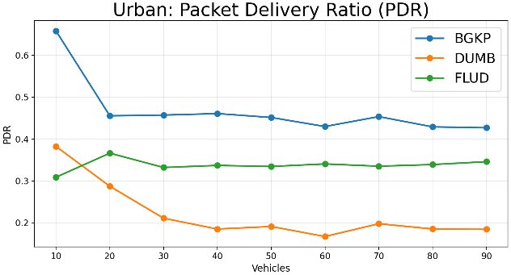
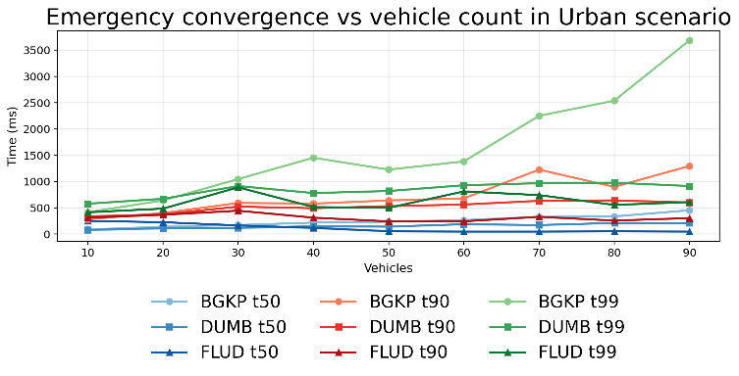
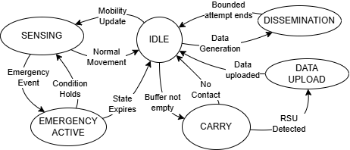

Trade-off design under fragmentation
- improved urban RSU delivery
- higher delay and overhead
- no consistent emergency advantage
Conclusion

- Designed BGKP and two baseline protocols
- Implemented in Contiki-NG / Cooja
- Generated urban mobility from OSM + SUMO
- Built highway mobility model in Cooja
- Processed logs into metrics and plots
Methodology

Urban Scenario (Wynyard Quarter)
- Highest urban RSU-delivered ratio
- Highest latency and transmission cost
- Emergency convergence not consistently best
Results

- Preferred peer selection
- Local decision making
- Opportunistic dissemination
- State-based emergency updates
- Bounded buffering
Key mechanisms

System Behaviour

Bounded Gossip-based Kernel Protocol
- Adaptive gossip forwarding
- Bounded retransmissions
- Store–carry–forward
- Local decision making
BGKP Protocol

Scenario

Highly dynamic networks and frequent fragmentation prevent reliable communication in VANETs.
Emergency messages must propagate even when:
- no routes exist
- connectivity is intermittent
Problem

Infrastructure-independent emergency dissemination
Reliable notification under intermittent connectivity
- operates under network fragmentation
- does not rely on RSU availability
- supports delayed and opportunistic delivery

Key Idea
Auckland University of Technology
Master of Engineering

